**QUESTION 2**

**Nagineni Sai lasya**

**16353784**

DATA VISUALIZATIONS

1.

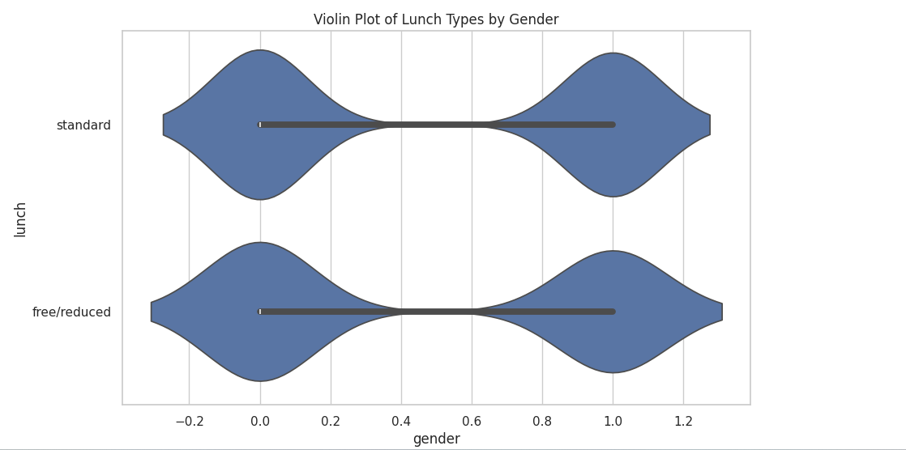

2.

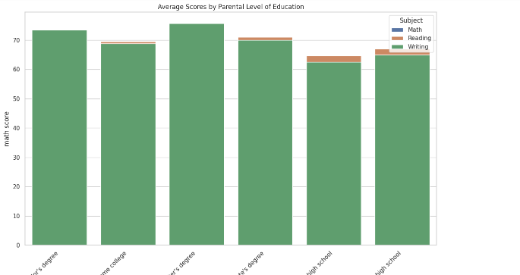

From this graph, i.e A bar graph makes it simple and clear to understand for me to analyize which level of education people getting how many scores in each subject. So that we can easily understand score distribution by parental level of education.

3.

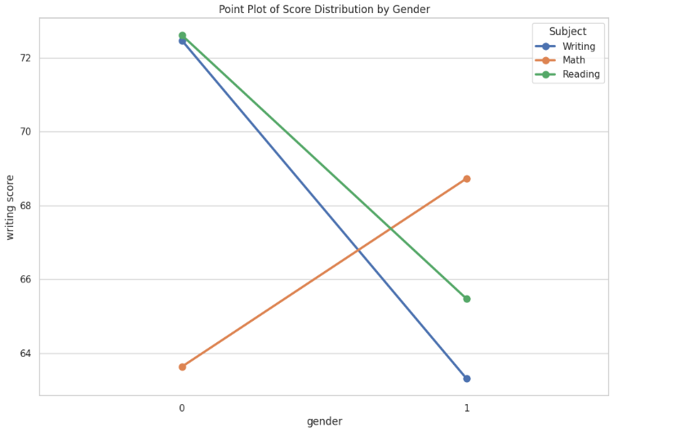

4. 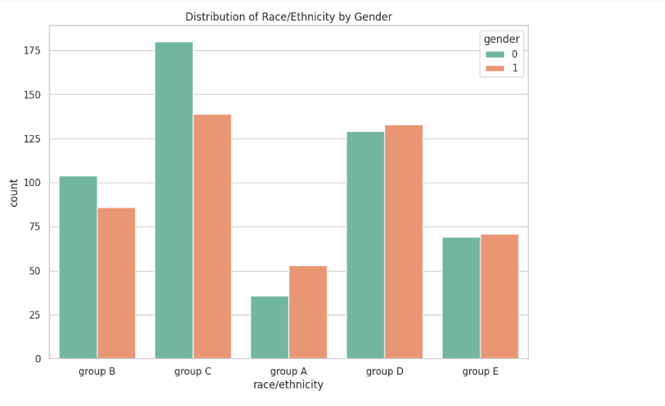

5. 